**AIM: DESIGN WEB APPLICATION TO PRODUCE AND CONSUME A WEB SERVICE & WCF SERVICE**

**Design Web Application to produce and Consume a web Service  
  
A) Create an XML web service that returns all the student details from the student table. Write an Application that uses this service to display student details in datagrid view control.**

**SOURCE CODE:**

**StudentService.aspx:**

<%@ Page Language="C#" AutoEventWireup="true" CodeFile="StudentService.aspx.cs" Inherits="StudentService" %>

<!DOCTYPE html>

<html xmlns="http://www.w3.org/1999/xhtml">

<head runat="server">

<title></title>

</head>

<body>

<form id="form1" runat="server">

<div>

<asp:GridView ID="GridView1" runat="server"></asp:GridView>

</div>

</form>

</body>

</html>

**StudentService.aspx.cs:**

using System;

using System.Collections.Generic;

using System.Linq;

using System.Web;

using System.Web.UI;

using System.Web.UI.WebControls;

using System.Data;

using System.Data.SqlClient;

using System.Configuration;

public partial class StudentService : System.Web.UI.Page

{

protected void Page_Load(object sender, EventArgs e)

{

WebService1 ws1 = new WebService1();

DataSet ds = ws1.GetData();

GridView1.DataSource = ds;

GridView1.DataBind();

}

}

**WebService1.asmx.cs:**

using System;

using System.Collections.Generic;

using System.Data;

using System.Data.SqlClient;

using System.Linq;

using System.Web;

using System.Web.Services;

using System.Configuration;

/// <summary>

/// Summary description for WebService1

/// </summary>

[WebService(Namespace = "http://tempuri.org/")]

[WebServiceBinding(ConformsTo = WsiProfiles.BasicProfile1_1)]

// To allow this Web Service to be called from script, using ASP.NET AJAX, uncomment the following line.

// [System.Web.Script.Services.ScriptService]

public class WebService1 : System.Web.Services.WebService

{

public WebService1()

{

//Uncomment the following line if using designed components

//InitializeComponent();

}

[WebMethod]

public DataSet GetData()

{

string connStr = ConfigurationManager.ConnectionStrings["narender_p9ConnectionString"].ConnectionString;

SqlConnection conn = new SqlConnection(connStr);

SqlDataAdapter da = new SqlDataAdapter("Select * from Student", conn);

DataSet ds = new DataSet();

da.Fill(ds);

return ds;

}

}

**OUTPUT:**

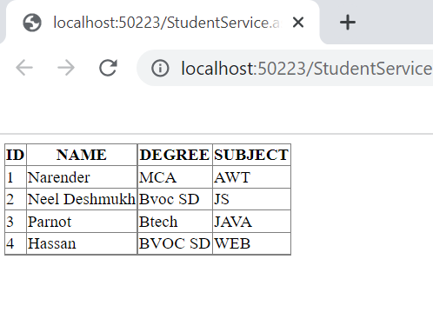

**Design Web Application to produce and Consume a WCF Service  
  
B) Design an Application to fetch data from the EMP table. Test the service and design a Web client to consume this service.**

**SQL SERVER:**

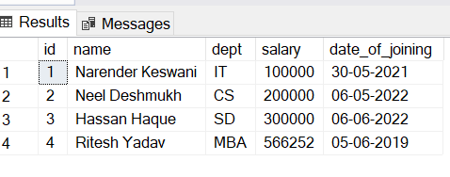

**WCF Web Service:**

**WebConfig:**

<add name="narender_p9ConnectionString" connectionString="server=. ; database=narender_p7; Trusted_Connection=Yes;" providerName="System.Data.SqlClient" />

**IService1.cs:**

using System;

using System.Collections.Generic;

using System.Linq;

using System.Runtime.Serialization;

using System.ServiceModel;

using System.ServiceModel.Web;

using System.Text;

using System.Data.SqlClient;

using System.Data;

namespace WcfService1

{

// NOTE: You can use the "Rename" command on the "Refactor" menu to change the interface name "IService1" in both code and config file together.

[ServiceContract]

public interface IService1

{

[OperationContract]

DataSet getNarendersEmployees();

}

[DataContract]

public class NarendersEmployees

{

int id;

string name;

string dept;

int salary;

string date_of_joining;

[DataMember]

public int Id

{

get { return id; }

set { id = value; }

}

[DataMember]

public string Name

{

get { return name; }

set { name = value; }

}

[DataMember]

public string Dept

{

get { return dept; }

set { dept = value; }

}

[DataMember]

public int Salary

{

get { return salary; }

set { salary = value; }

}

[DataMember]

public string Date_of_joining

{

get { return date_of_joining; }

set { date_of_joining = value; }

}

}

}

**Service1.svc:**

using System;

using System.Collections.Generic;

using System.Linq;

using System.Runtime.Serialization;

using System.ServiceModel;

using System.ServiceModel.Web;

using System.Text;

using System.Data;

using System.Data.SqlClient;

using System.Configuration;

namespace WcfService1

{

// NOTE: You can use the "Rename" command on the "Refactor" menu to change the class name "Service1" in code, svc and config file together.

// NOTE: In order to launch WCF Test Client for testing this service, please select Service1.svc or Service1.svc.cs at the Solution Explorer and start debugging.

public class Service1 : IService1

{

public DataSet getNarendersEmployees()

{

string connStr = ConfigurationManager.ConnectionStrings["narender_p9ConnectionString"].ConnectionString;

SqlConnection conn = new SqlConnection(connStr);

conn.Open();

SqlCommand cmd = new SqlCommand("Select * from employees_of_narender", conn);

SqlDataAdapter sda = new SqlDataAdapter(cmd);

DataSet ds = new DataSet();

sda.Fill(ds);

cmd.ExecuteNonQuery();

conn.Close();

return ds;

}

}

}

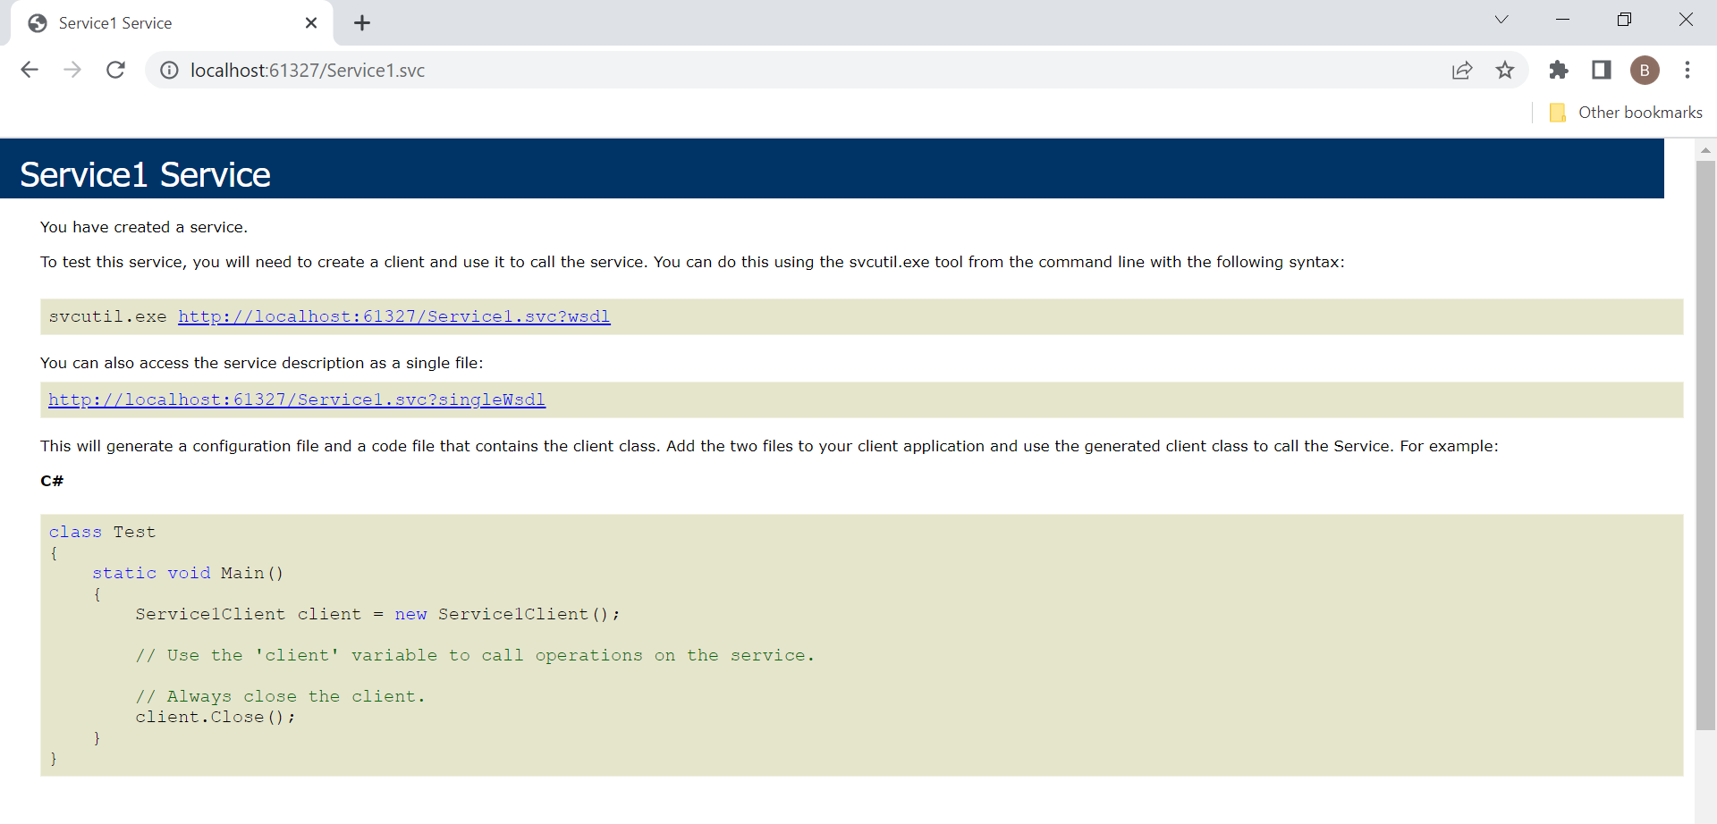

**Windows Forms App:**

**Form1.cs:**

using System;

using System.Collections.Generic;

using System.ComponentModel;

using System.Data;

using System.Drawing;

using System.Linq;

using System.Text;

using System.Threading.Tasks;

using System.Windows.Forms;

namespace WindowsFormsApp9BWCF

{

public partial class Form1 : Form

{

ServiceReference1.Service1Client obj = new ServiceReference1.Service1Client(); // Add service reference

public Form1()

{

InitializeComponent();

DataSet ds = new DataSet();

ds = obj.getNarendersEmployees();

dataGridView1.DataSource = ds.Tables[0];

}

}

}

**ADD SERVICE REFERENCE:**

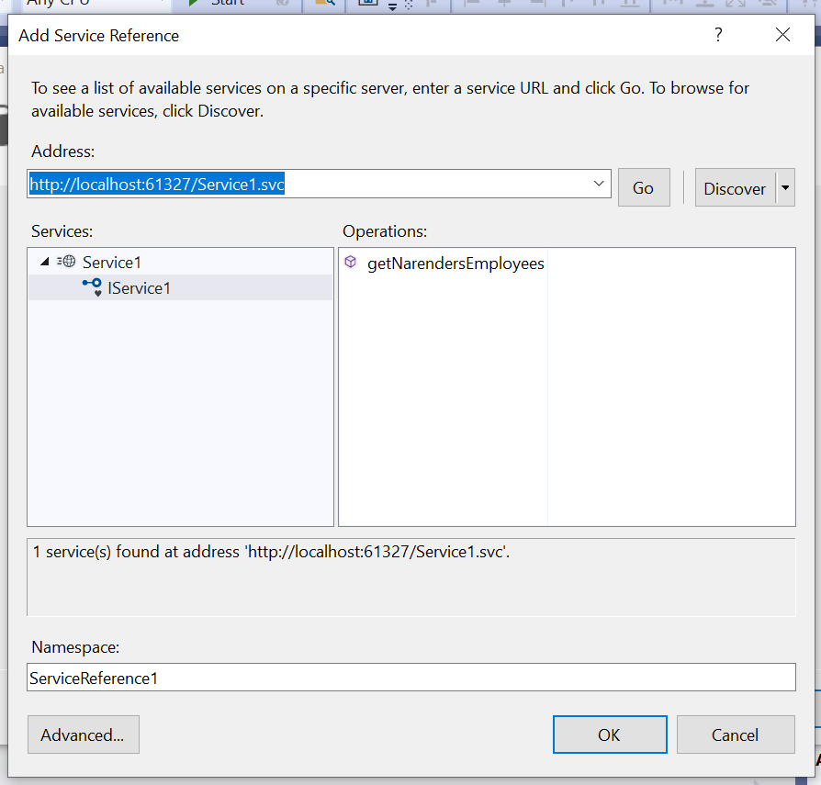

**OUTPUT:**

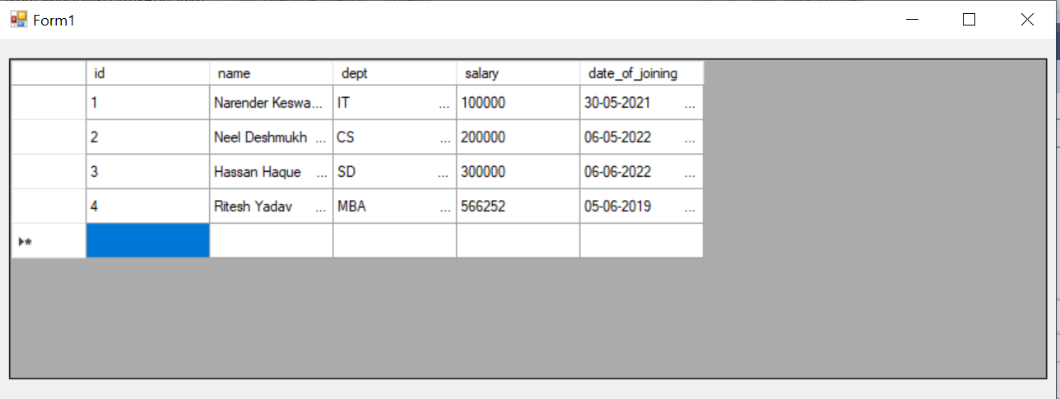

**CONCLUSION:**

From this practical, I have learned & implemented the creation & consumption of webservice in asp.net.